Lab 5.7 CronJobs

- Create a cronjob.yml file as shown below:
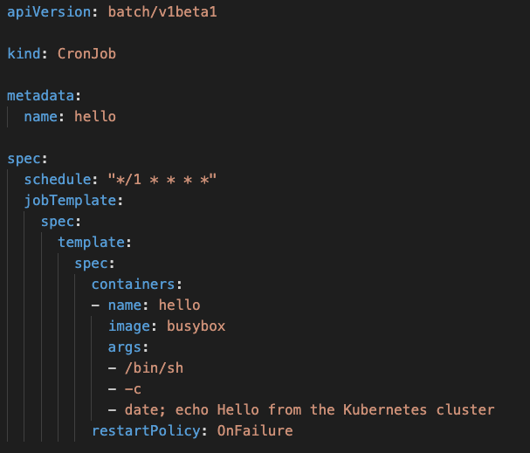

- Create a CronJob
kubectl create -f cronjob.yml

- Check the completion status of the job
kubectl get jobs

- Have a look at the logs of the Pod
kubectl logs -f <podName>

- Have a look at more details of the Job
kubectl describe job

